JSP

What is JSP – (introduction)

A JSP page looks similar to an HTML page, but a JSP page also has Java code in it. We can put any regular Java Code in a JSP file using a **scriplet tag** which start with <% and ends with %>. JSP pages are used to develop dynamic responses.

It’s a dynamic web pages that will display different content each time it is viewed/changed by request or responses.   
  
It is easy to update and manage, as JSP supports data-driven web pages.  
  
In this project, I will do the HTML page along with inserting the Java code in it using JSP.  
  
  
1. This is one of the examples of JSP file, the addStudent.jsp file, it contains the Java coded credential handler. That will perform the add student to the system.  
  
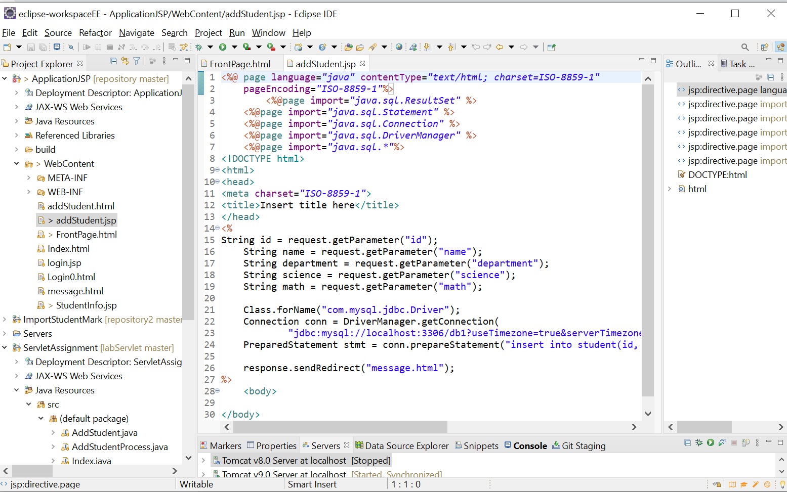

2. The front page will be handled by the HTML file, as it provides an easy means of creating an interface.  
  
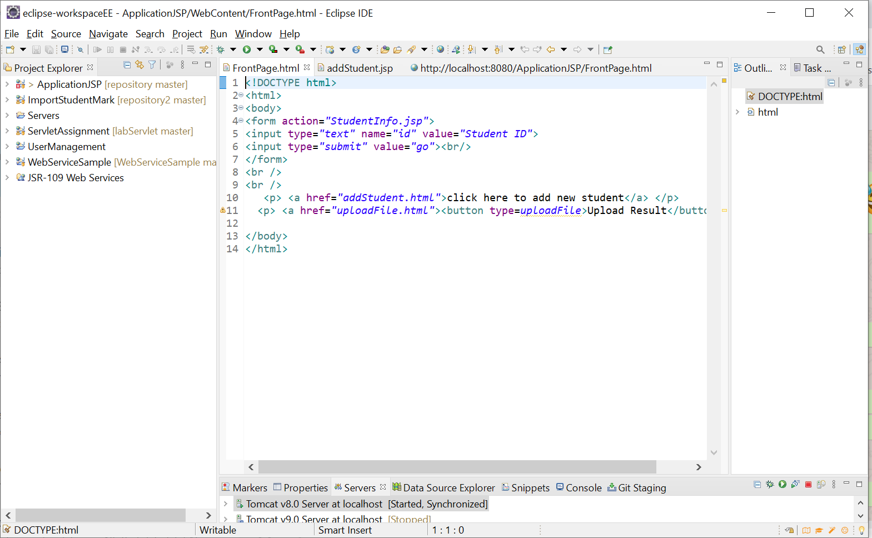  
  
here are the web pages.  
  
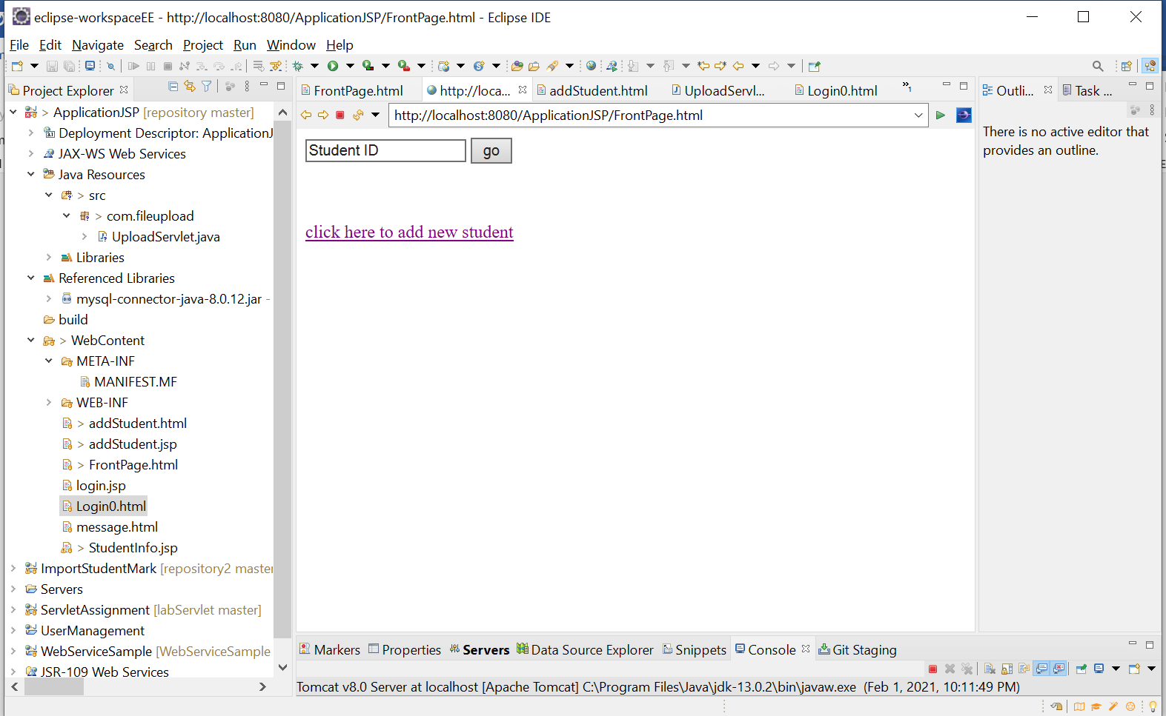

I inputted the 195988 as a student ID and it gave me the result of a student with that ID.  
  
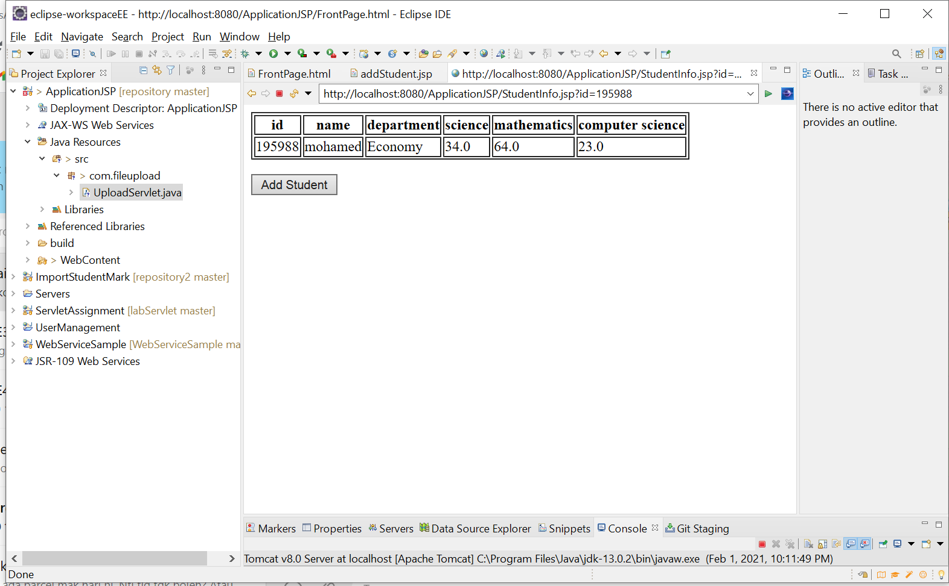

I added a new student.

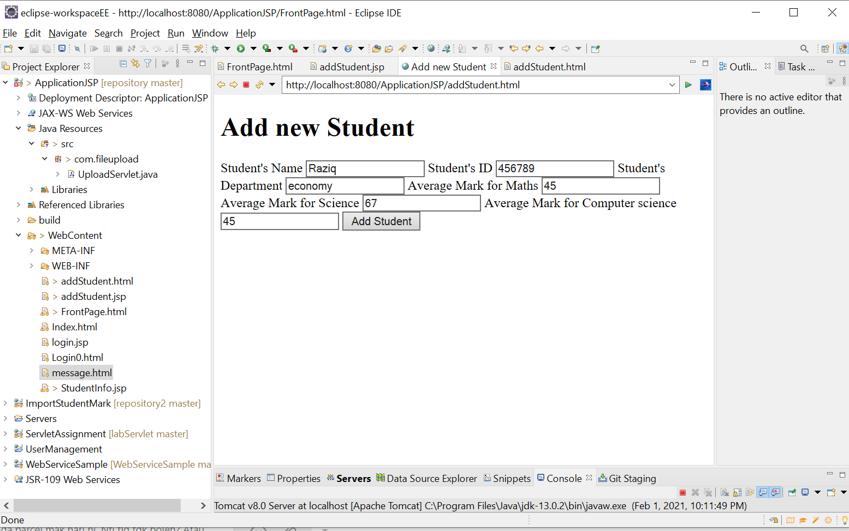  
  
  
Successfully added

